Reliability of Protocols

**Protocol 1:**

This is a simple Request Reply pattern. The Game Manager (GM) will know that the Lobby received the GM_Join_Lobby message when it received the SignId message back. The Lobby will know that the Game Manager received the SignId message when it reaches the end of its timeout without receiving a duplicate message.

Initiator Retry Loop - The GM will send the initial message and wait three second for a reply. If no reply come in before 3 seconds has passed, the GM will resend the initial message. The GM will retry the initial message up to three times before canceling the conversation.

Responder – If the Lobby receives the initial message it will create a conversation and send a response. The conversation will then wait at least three seconds before stopping the conversation. If in the wait time a duplicate initial message was received the Lobby will resend the response and restart the wait time.

**Protocol 2:**

This protocol is very similar to Protocol 1 and will be handled the same way.

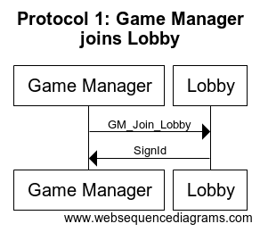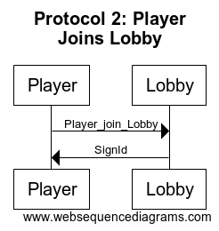

**Protocol 3:**

Because the ordering of the message made it difficult for reliability in this protocol the ordering of the messages was changed and messages where added. Each request and response in the Reliable protocol 3 will now follow the same patter as Protocol 1.

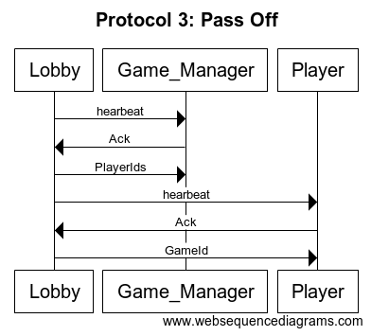 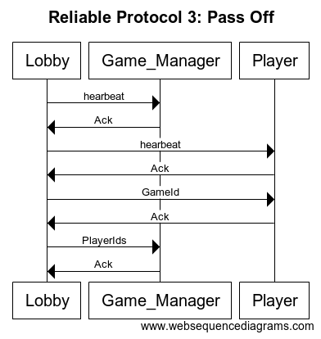

**Protocol 4:**

Because the heartbeats of this message were unnecessary, and we could increase the reliability by trimming it down many messages were cut out of protocol 4. Each request and response in the Reliable protocol 4 will now follow the same Request-Reply pattern as Protocol 1. Players may receive an error message back from the Game Manager if their boards are not in accordance to the Game Managers specifications.

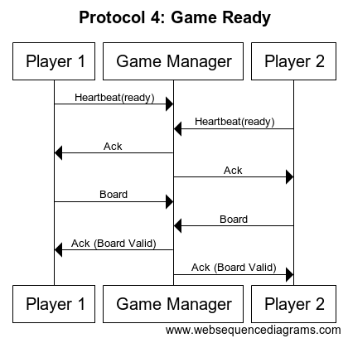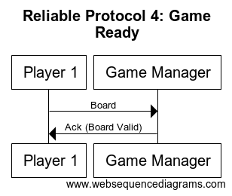

**Protocol 5:**

Because the ordering of the message made it difficult for reliability in this protocol the ordering of the messages was changed and messages where added. Each request and response in the Reliable protocol 5 will now follow the same patter as Protocol 1.

Protocol 5 was also split into two different protocol because the time between sending the Ack and Shooting could be lengthy. It will be more reliable to have them in different conversations. Those conversation will alternate back and forth. 5 telling a player its there turn and 5.2 giving the results to a player after they shoot. At the finish of 5.2 the Game Manager will start 5 with the other player.

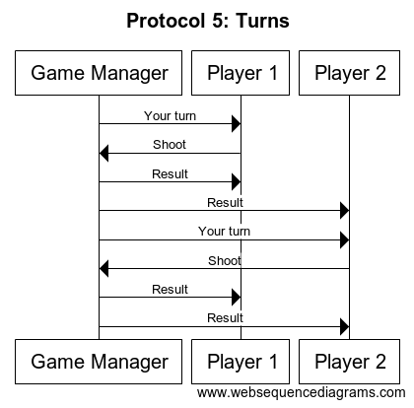 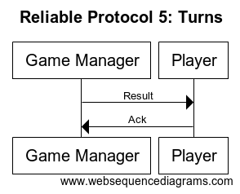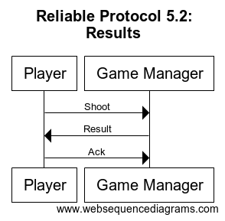

**Protocol 6:**

Because of the changes in protocol 5 each player would have received the result of the game before this protocol, this makes the result messages in protocol 6 unnecessary. This protocol will now just notify the Lobby of the game ending. Each request and response in the Reliable protocol 6 will now follow the same patter as Protocol 1.

